HELLENIC REPUBLIC |  | FACULTY OF HEALTH SCIENCES  DEPARTMENT OF MEDICINE  MASTER OF SCIENCE  “Application of endoscopic surgical techniques in gynecology”
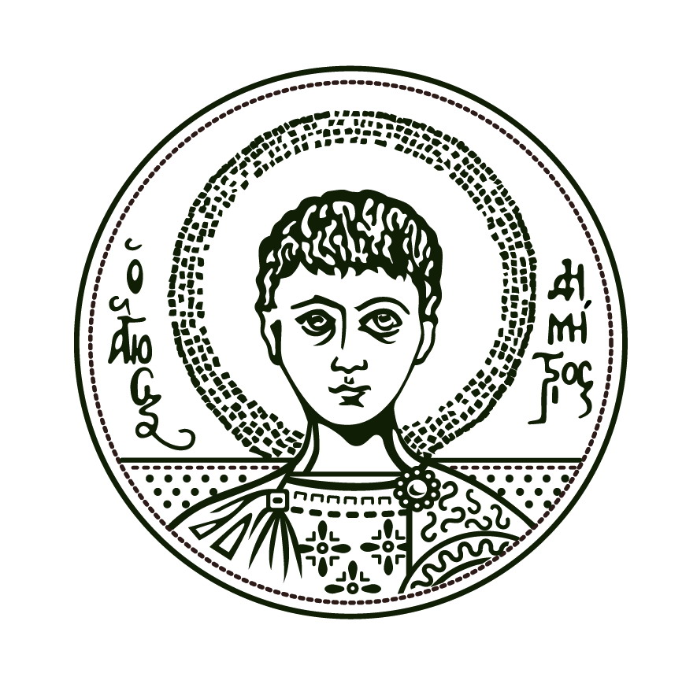 |  | Director: Angelos Daniilidis, Professor
ARISTOTLE UNIVERSITY Of  THESSALONIKI |  | Information: Alexandra Karagianni  Email: msc-endoscopicsurgery@med.auth.gr

Thessaloniki, / /
Application form

Please accept my application form for the MSc
“Application of endoscopic surgical techniques in gynecology”

Name

Surname

Father name
and surname
Mother name
and surname
Nationality

Address

Zip code

City

Phone
E-mail

Tax Identification number (ΑΦΜ)
Financing body
(ΔΟΥ)
I hold a bachelor / MSc / PhD / other degree(s) in/from
I agree to abide by the MSc program regulations | YES □ NO □
Attachments

1. | Bachelor / MSc / PhD / other degree(s).
2. | Recognition Degree from ΔΟΑΤΑΠ (if needed)
3. | Recently updated Curriculum Vitae, with details about education, training, work experience, academic publications and academic achievements
4. | Proof of competency in English language.
5. | Photocopy of personal ID or passport with personal details or an equivalent state-issued document
6. | Letter of Intent
7. | Other documents if available (proofs of profession or research experience, reference letters, etc)

